University of Gujrat
Department of Software Engineering
Submitted by:
Muhammad Aliyan
25021598-245
Section:
AB
Submitted to:
Miss Reema Chaudhary
Date Submitted:
12/8/2025
Contents
Q1: Library Management (Mini System) 3
Code 3
Output 4

Q1: Library Management (Mini System)

Code
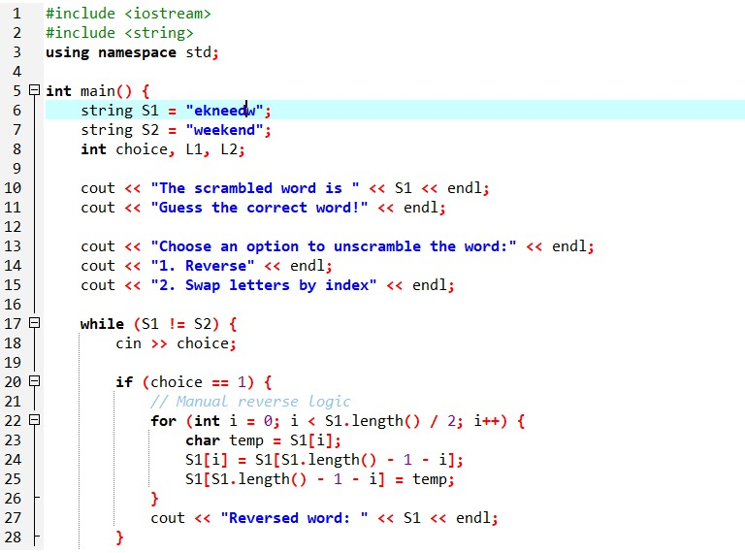

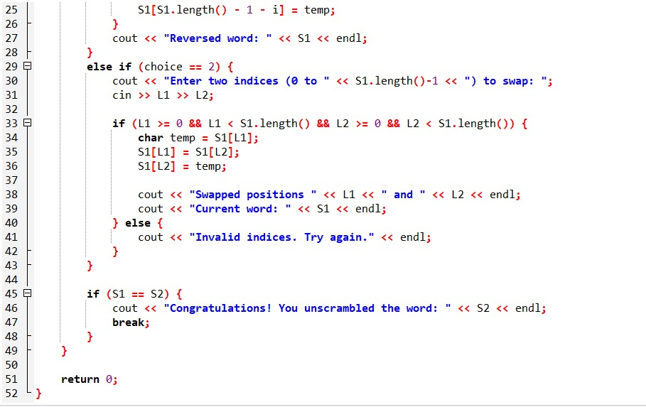

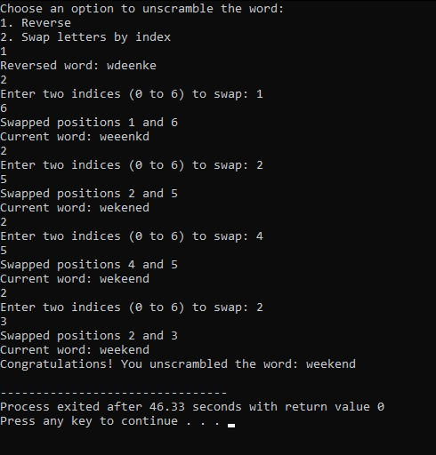
Output

Q2: Temperature Data Processing

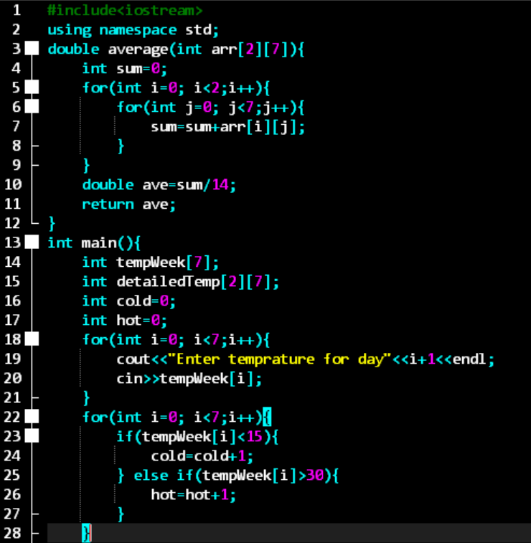
Code
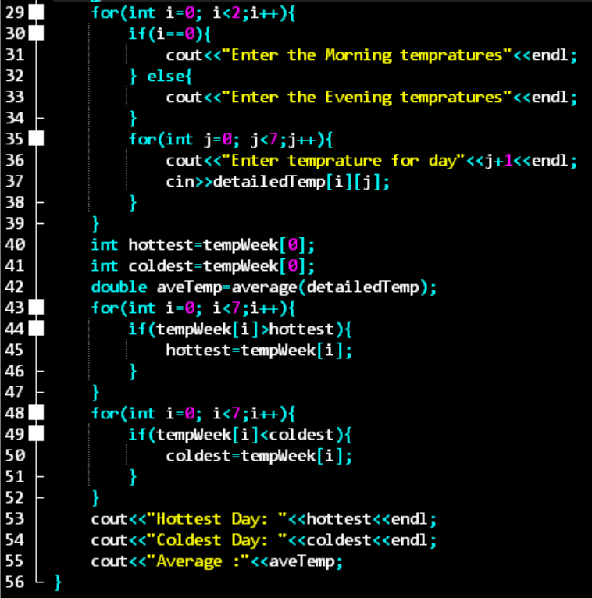

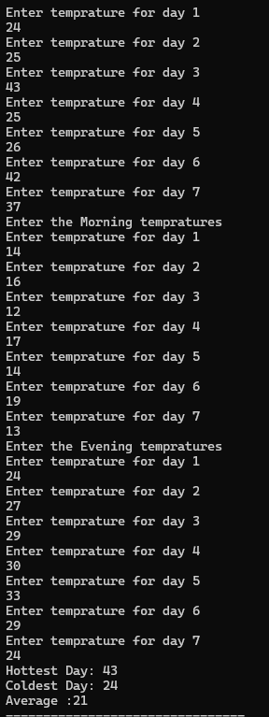
Output

